The Alliance Community Church

Lighthouse Newsletter
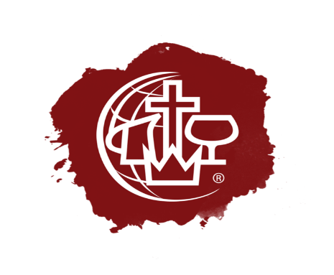
Jesus Our Savior/ Jesus our Healer/ Jesus Our Sanctifier/ Jesus Our coming KING!
“I am the way the truth and the life, no one come to the Father But through Me.” (John 14:6)

Je

Thy Kingdom Come

Thy Will be,

DONE!

How does the Church respond to Asbury? This is the question in the minds of many Christian Theologians. Is a revival right now in the works or is this just a flash in the pan? It really boils down to our response to what Jesus taught us about prayer. A key statement is this in the Lords Prayer. “Thy Will Be Done.” It is not our will but God’s will that must concern us, was it man that begun this revival in Asbury? No it began after a prayer service was held and students returned. So, the next question is why? No one can really explain why, many just knew they had to return. What is interesting to note is that when city leaders wanted it to stop because traffic was beginning to be a problem, school officials said that they could not stop it since they never started it to begin with.
Is it the Spirit of God doing His will? Only our prayers can answer that, and how should we as Christian respond? As a pastor I take hope in the fact that there is beginning to be a new awakening in the Spirit. For too long we have seen the enemy have a field day with adults and students alike. Hopelessness has st in at schools and businesses, suicide has become a normal piece in the news. So when we see an event like this it should encourage us that Jesus has come to our rescue. He gave us encouragement in scripture. “I have told you these things, so that in me you may have peace. In this world you will have trouble. But take heart! I have overcome the world.” (John16:33)

We can also encourage one another, it may not always be possible to meet but with today’s technology we can meet worship, study, and pray together. The Alliance Community Church has developed our own system to be able to broadcast our services and events all over the world. Live stream is a wonderful resource for reaching many in areas where the Gospel is limited. Maybe you are thinking Pastor aren’t you concerned about your own church growth? Sure as any Pastor would be, but I trust that God will take care of that, the truth is we are to be Kingdom Builders, not just Church builders.
It is when we commit ourselves to God and Him alone that we realize why Jesus taught us to pray and take to Heart that we can do nothing on our own power, it all come from the Father. So we Pray, “ Thy Kingdom Come, Thy will be Done on Earth as it is in Heaven.” Amen!

Online Giving

We are pleased to let everyone know that you can give to our ministry right on line either on the live stream or our website just look for the donate button. Every dollar you send will be used to further the ministry both online and in our city. When you donate be sure to signup for our Monthly newsletter that you see right here. There will be way more to share in the coming months.

