The Alliance Community Church

Lighthouse Newsletter
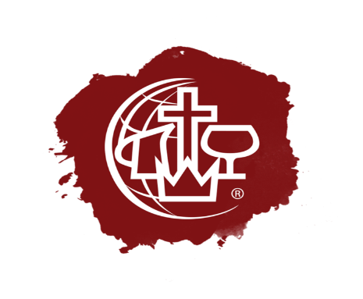
Jesus Our Savior/ Jesus our Healer/ Jesus Our Sanctifier/ Jesus Our coming KING!
“I am the way the truth and the life, no one come to the Father But through Me.” (John 14:6)

Je

Thy Kingdom Come

Thy Will be,

DONE!

Forget Not The Children

We are blessed to have Children in our church, but sadly not all congregations can say that. I was reminded of that sad fact when a new couple came to visit us one Sunday Morning, they stated, “It was wonderful to see the Children, many churches we visit have none.” Proverbs 22:6 states, “Train up a child in the way he should go; even when he is old, he will not depart from it.” What do we want the future to look like? Is the Church destined to be empty? Will it be an institution devoted to those in their autumn years? I firmly believe based on the knowledge given to me by the Spirit of our Lord that this is never to be. But we must as a church look to the future of the church and to the future of this Nation. In order for Children to become the future Christians they need a firm foundation, this is where it begins for us because God has placed that foundation in us, called, The Holy Spirit.
We spend countless hours planning an outreach for families hoping that there would be children we can minster to, that is good but what would be more effective is if we targeted our outreach to specifically Children. One thing I have noticed is that the generation coming up today is searching for something more. They are hungry for what has been lost in our generation, Jesus. What I find interesting is churches that embrace a worship theme that is modern and geared to a young generation find that there is growth not only in the attendance of young people but also the older people of the community.
It may be because of what John wrote in his 3rd letter; I have no greater joy than to hear that my children are walking in the truth. 3 John 1:4 When we see young people getting involved in ministry, seeing the joy on their faces as they begin to understand Jesus, celebrating the joy of being a part of something bigger, it reminds us of how we felt when Jesus first came to us. Is it work yes, but let’s admit it, it is truly a labor of love and one that blesses even the most stubborn heart. Amen

Online Giving

We are pleased to let everyone know that you can give to our ministry right on line either on the live stream or our website just look for the donate button. Every dollar you send will be used to further the ministry both online and in our city. When you donate be sure to signup for our Monthly newsletter that you see right here. There will be way more to share in the coming months.

VBS is BACK

Yes, it is true we will be bringing back our VBS program this year. We are fortunate to have a group in our area that will hold the VBS for us at our church, they belong to, The Child Evangelism Fellowship of the Empire State. They have been around for years and will work with schools and churches to help promote a healthy and growing children’s ministry. Our VBS this year will be August 7-11 from 9am to 11:30 am at our Church, we are encouraging parents to get their children signed up and plan for a great week.

Service on Seneca Lake

We are again having our Service on the Lake at Seneca Lake State Park shelter #1 the Date is set for August 6th at 11am with a cookout lunch to follow. Plan now and bring the Family. Our District Superintendent David Linn will deliver a fantastic message that he is noted for. We will plan on doing things with the Children that arrive. It will be a time of renewal blessed by our Lord as it has been every year. Baptisms will be done in the lake for those that request it. Come join us and enjoy our Lord.

We are Still Building Our Band

Do you have a passion for Music? Why not turn your passion for music into a tool for God to use in others? We still need keyboard players, Guitar players, singers and all who have a talent for music. Young or old you are welcome to join us, Christian or not let’s make music together. Call Pastor Jon or send an email for further information.

