The Alliance Community Church

Lighthouse Newsletter
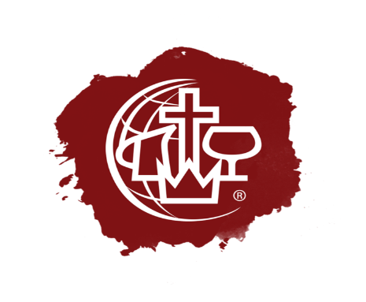
Jesus Our Savior/ Jesus our Healer/ Jesus Our Sanctifier/ Jesus Our coming KING!
“I am the way the truth and the life, no one come to the Father But through Me.” (John 14:6)

Je

“Is your church conforming?”

Romans 12:1-2; Paul urges all his followers to not conform to the patterns of this world but to be transformed by the renewing of our minds. I have to ask though are we really transformed in the Church today in America or are we kidding ourselves and in reality, we are conforming to the worlds ideas of where the church belongs in American society? It is true that God tells us we must submit to the Authority, which is our Government, but is it submitting or capitulating to it? When we stay inside our churches and make no effort to spread the word of God past our sanctuary doors are we not conforming since the reasons we use are, “I don’t want to upset others.” Or “People don’t want to hear the Truth.” Man’s law is fine as long as it does not violate God’s law or God’s command to His people, us. Matthew 28:16 Jesus tells us to go make disciples of all nations. This is a command we know as the Great Commission. The Church Jesus body, us we have been commissioned by God to take the Good News of the Gospel to every person of every nation and let them know their God is waiting for them and has forgiven them.
Church, we need to be renewed, we need to be reminded that Jesus is with us, He has greater authority than any government in the World. We speak with the authority of our Father in Heaven, He is not timid, He wants everyone to know how much they are loved and what a great future they have in Him. Don’t we owe others the right to know that this world is not going to lead them to everlasting life? Let’s be present and transformed.

Online Giving

We are pleased to let everyone know that you can give to our ministry right on line either on the live stream or our website just look for the donate button. Every dollar you send will be used to further the ministry both online and in our city. When you donate be sure to signup for our Monthly newsletter that you see right here.

Christian Coaching
Meet Cathy Landschoot She is our Christian crisis coach. Cathy is fully trained in all aspects of crisis and Life coaching, from substance abuse to anxiety Cathy is a God led caring person that is willing to help you in any way as you face the demons in your life. She is available for appointments either in person or by zoom. Also, She is available for Speaking engagements for your group. Let’s face it right now people are dealing with issues we have not seen in the past. We see children in our schools committing suicide, overdosing, all looking for something to help them cope with the world around them. But we all know that there is only one answer in our time of need, Jesus and everything Cathy does points to the healing power of faith in our Savior and king. Cathy can be reached through her website, www.makeitmatterministries.org

Church Band
Our Band is coming together slowly but we are making steady progress. If you know anyone that plays an instrument or likes to sing have them Join us at the Church 7pm each Tuesday evening. Our sound system is one of the best with a professional sound engineer. He is also coordinating the band. It matters not if you are a Christian or not if you like to play then you are invited to jam with us, just show up.

Happening this Month

I am pleased to announce that 3 new elders have been installed in our Church as of Sunday June 4th ,2023. Jay Coleman, Brian Landschoot, and Jeff Komula were elected by the Congregation of the Alliance Community Church and installed. They will Join our two current elders John Braungart and Roy Atkinson in senior leadership roles to our congregation. Praise the Lord for these faithful men. Pictures will follow.
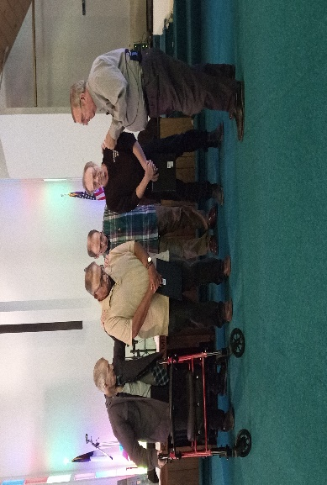
Jay Coleman(L) and Jeff Komula(R) Being prayed over and installed as Elders.
VBS We will be offering VBS this year for the first time in 3 years. It is scheduled for August 7-11 9am-11:30am at our Church. We look forward to having a number of students from the community join us for fun and time with the Lord.
Ministry We are pleased to announce that Josh Aries, one of our young fathers here at our Church has responded to the Fathers call and has been accepted into the Alliances Leadership Training program. Josh is now on a path to Ordination as He begins his ministry studies. I ask everyone to pray and encourage Josh on his journey.
The Elders Board- Will meet June 27 at 6pm at the Church.
The Governing Board- Will meet June 19th at 6:30 pm at the Church.
Father’s Day, Sunday June 18th we honor our fathers, those who are with us and those who are with the Lord. But we must not forget the greatest father we have, our Father in Heaven. He is our true creator, and His love for us has to be the example of love that we as fathers must show our own children. Don’t forget your Father, but fathers don’t forget to hug and love your Children, they are truly a gift from the one Father that truly loves you.

